**Task 1: Manipulating Environment Variables**

• Use printenv or env command to print out the environment variables. If you are interested in

some particular environment variables, such as PWD, you can use "printenv PWD" or "env |

grep PWD".

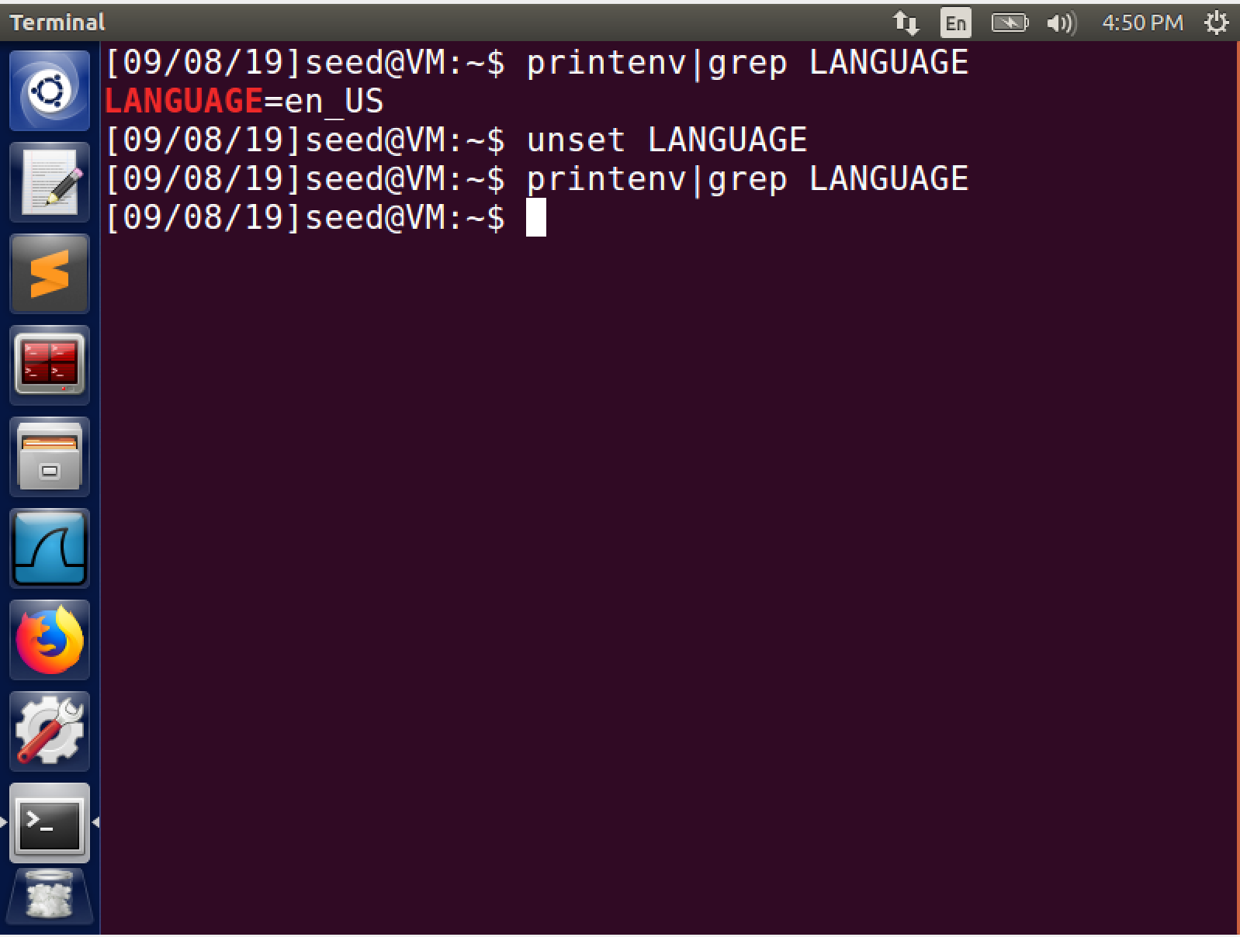

I used the grep command to search for the LANGUAGE environment variable from the list of environment variables.

• Use export and unset to set or unset environment variables. It should be noted that these two

commands are not seperate programs; they are two of the Bash’s internal commands (you will not be

able to find them outside of Bash).

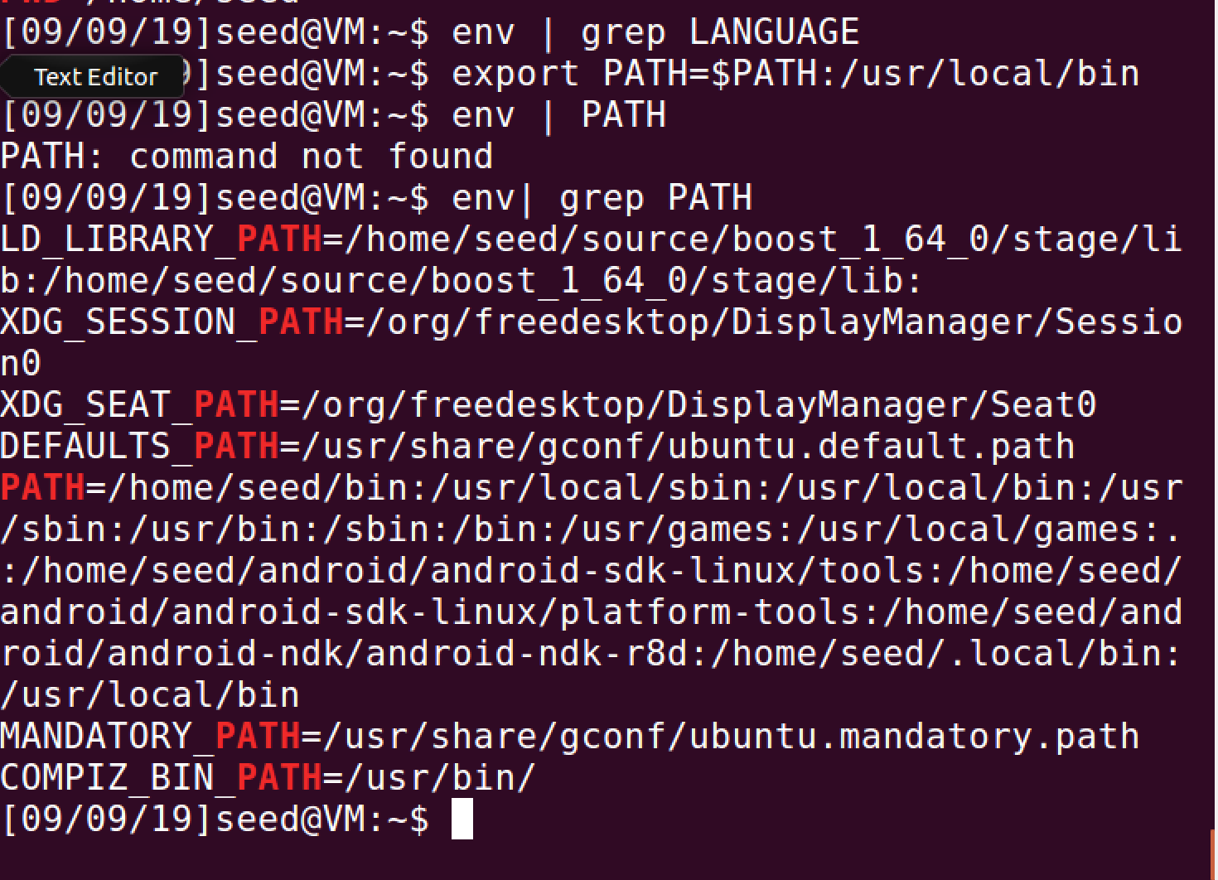

Here I unset the language variable using the unset command and set the Path variable(adding to the default PATH ) using the export call.

Task 2:

Observations:

There are no differences between the environment variables of the child and the parent process.

This is clear from the output of the diff command showing that the child inherits all the environment variables from the parent process

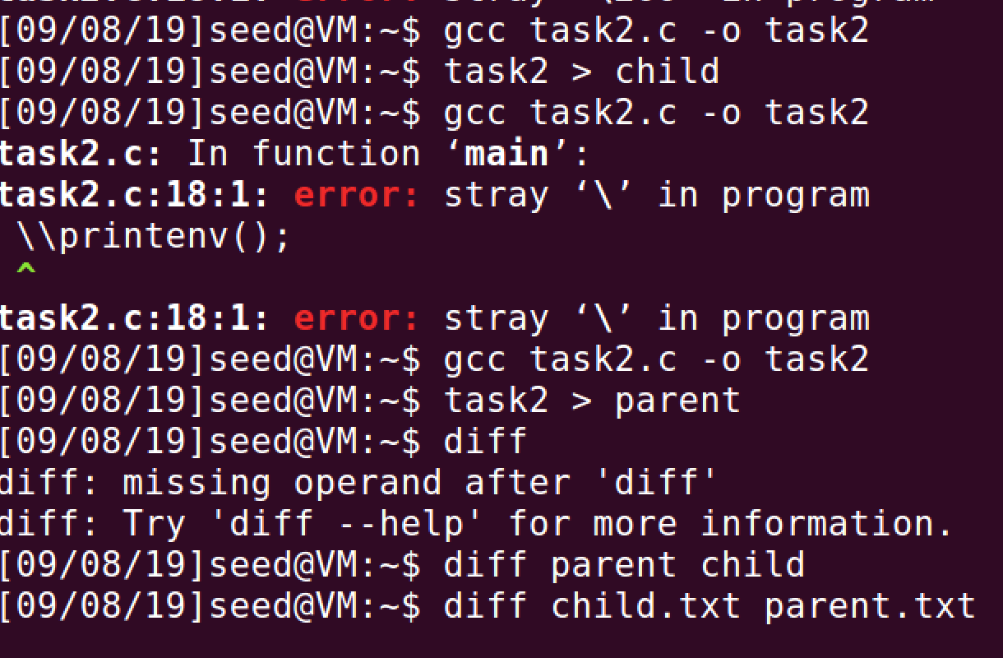

Task 3

Case 1

The execve call directly calls the OS to perform a given command. In the first case we are calling env using the argument ‘argv’ and not passing any environment variables. This renders a blank file when we print the environment variables using the env command, in the first scenario.

Case 2:

In case 2 we pass the array of environment variables ‘environ’ in the environment variables section of the execve call. This generates a file with the environment variables passed to it.

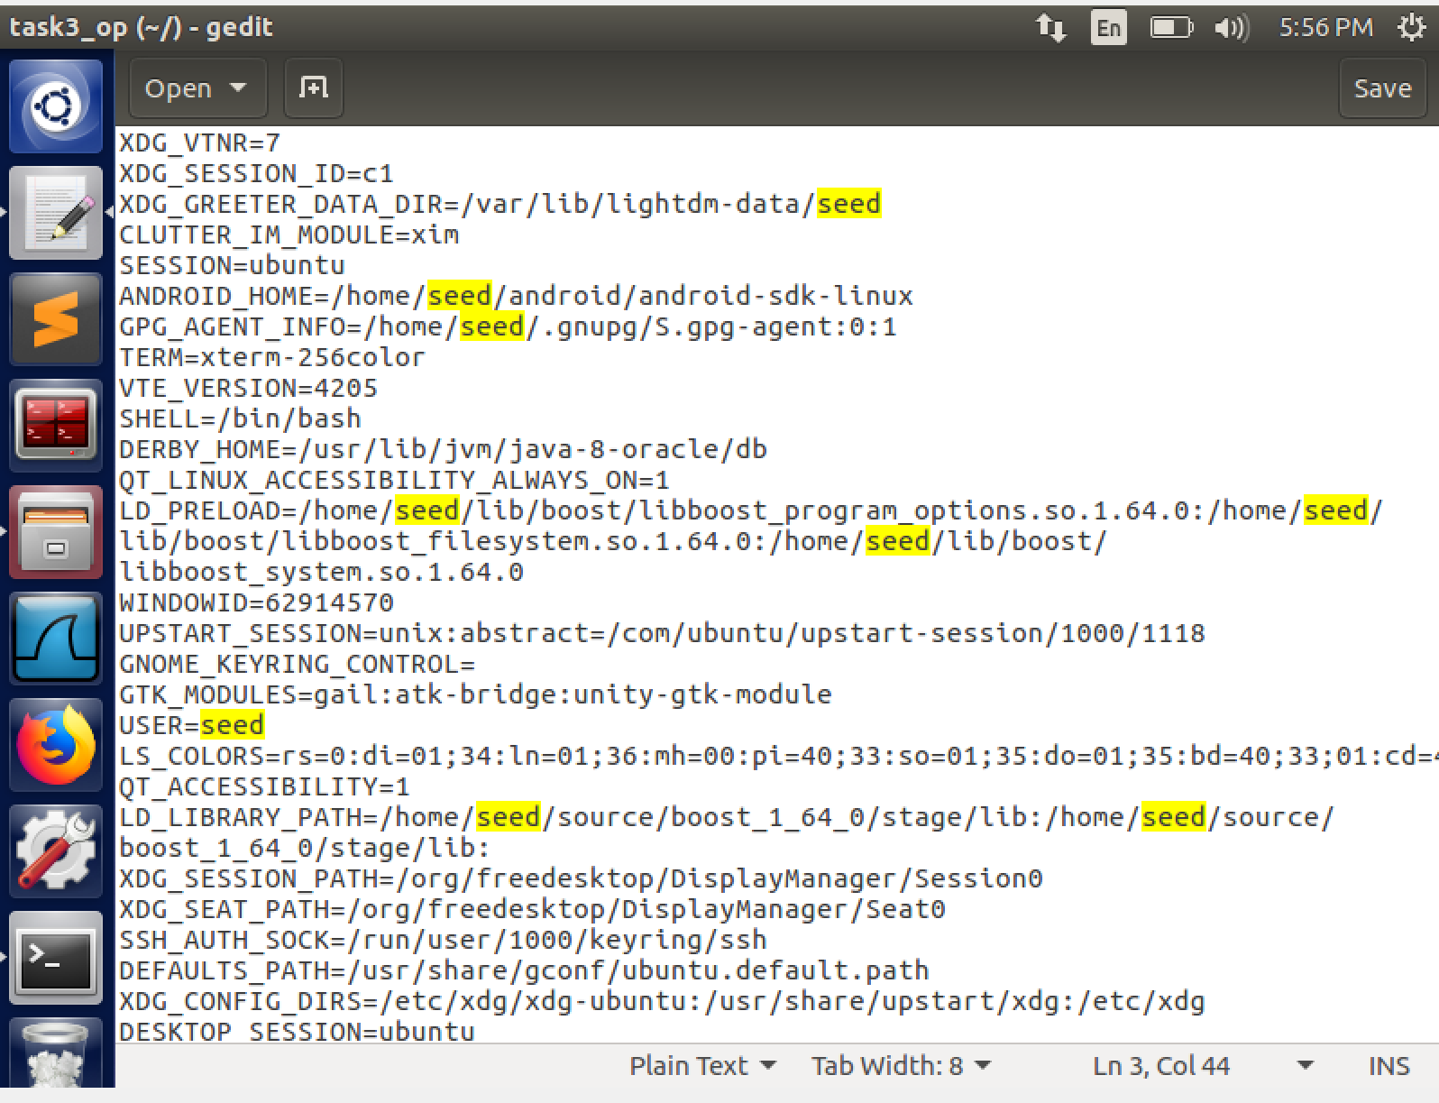

Task 4:

We use the system() function to run /usr/bin/env. We can verify from the screenchot that system() inherits the environment variables of the calling process. We can further verify this by changing ‘/usr/bin/env’ to ‘ls’. This gives us the output as the list of all files in the default path

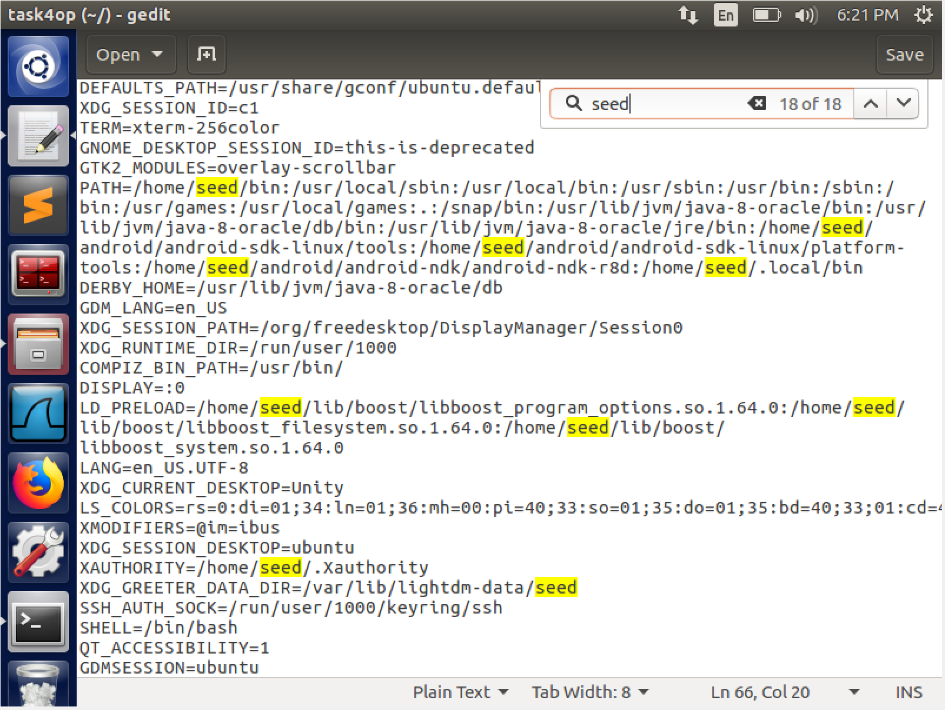

Case 2 (change to ls) 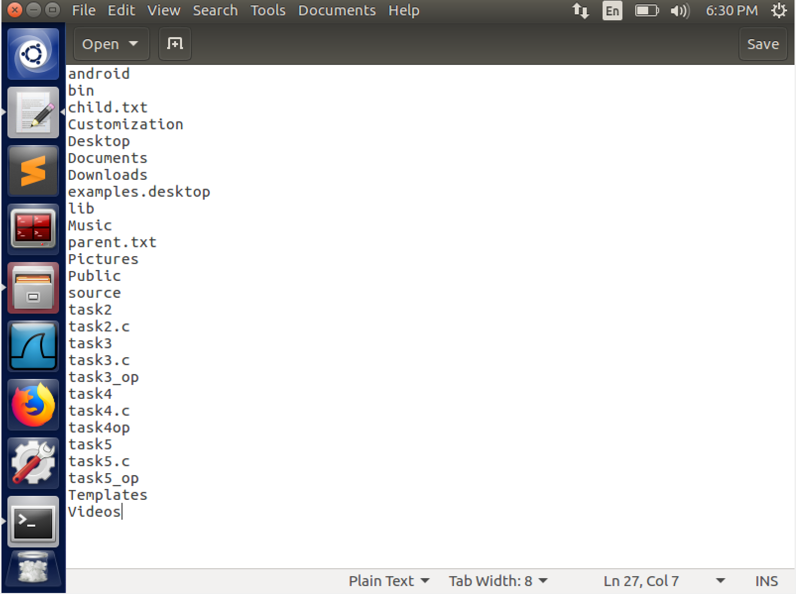

Task 5

WE compile the given program as task5 and make it a setuid program.

After that, we use the export command to set the environment variables to pass to the child process

We print all the environment variables in a txt file and notice that all the variables except the LD_LIBRARY_PATH variable is not inherited by the child process. This provides protection against malicious code.

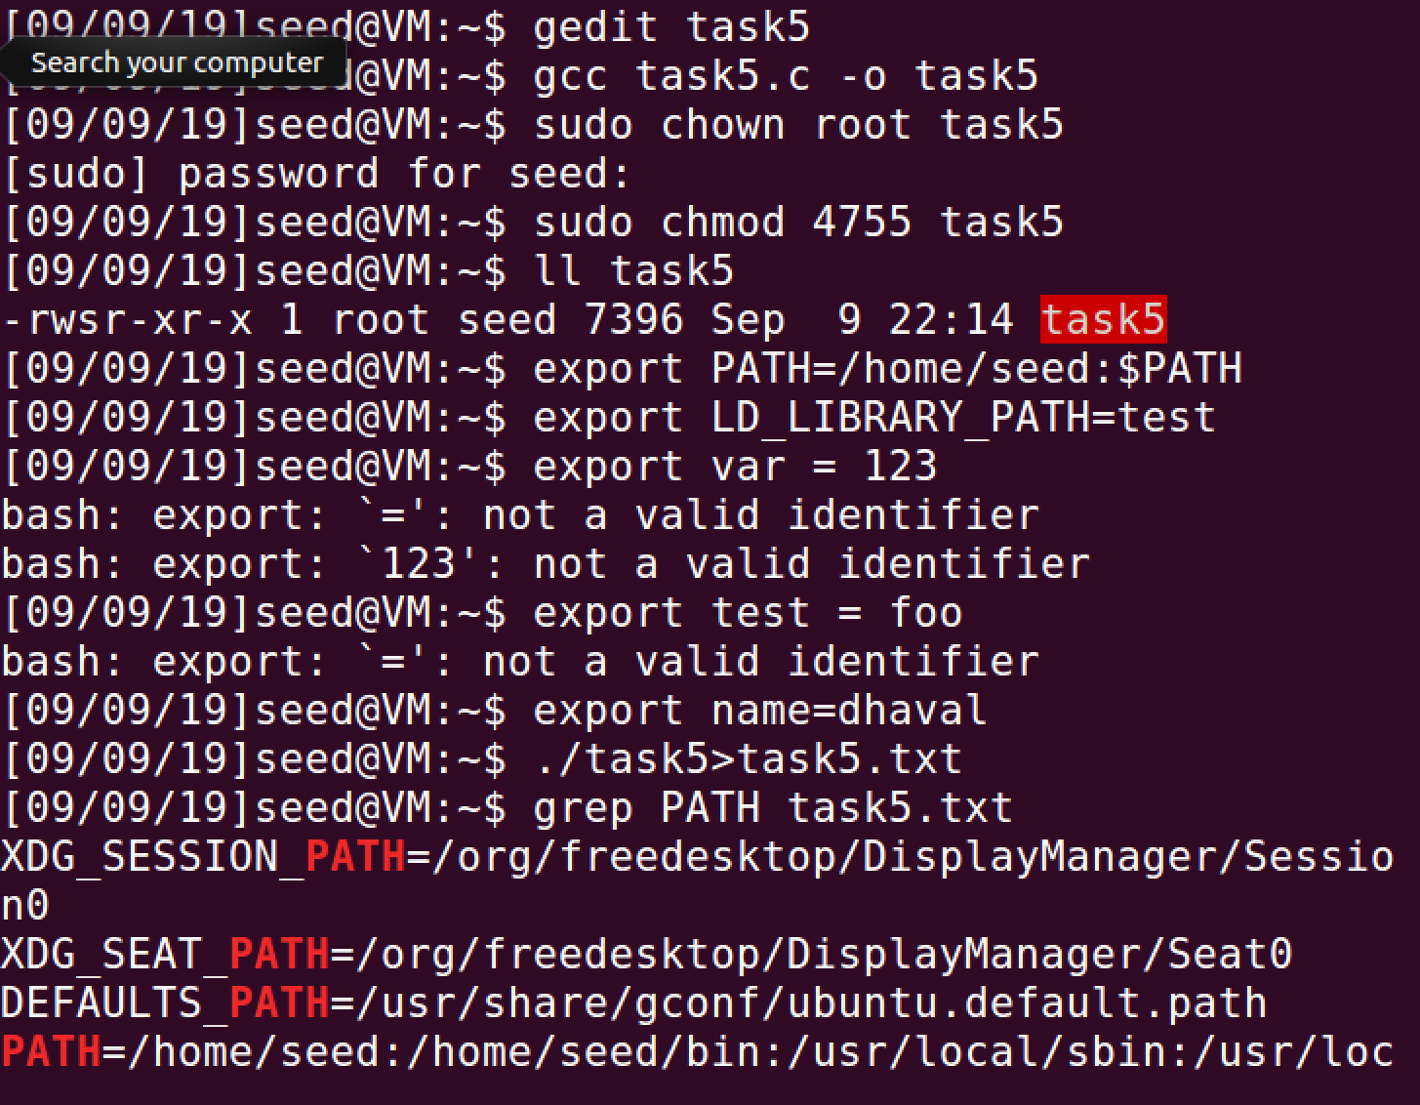

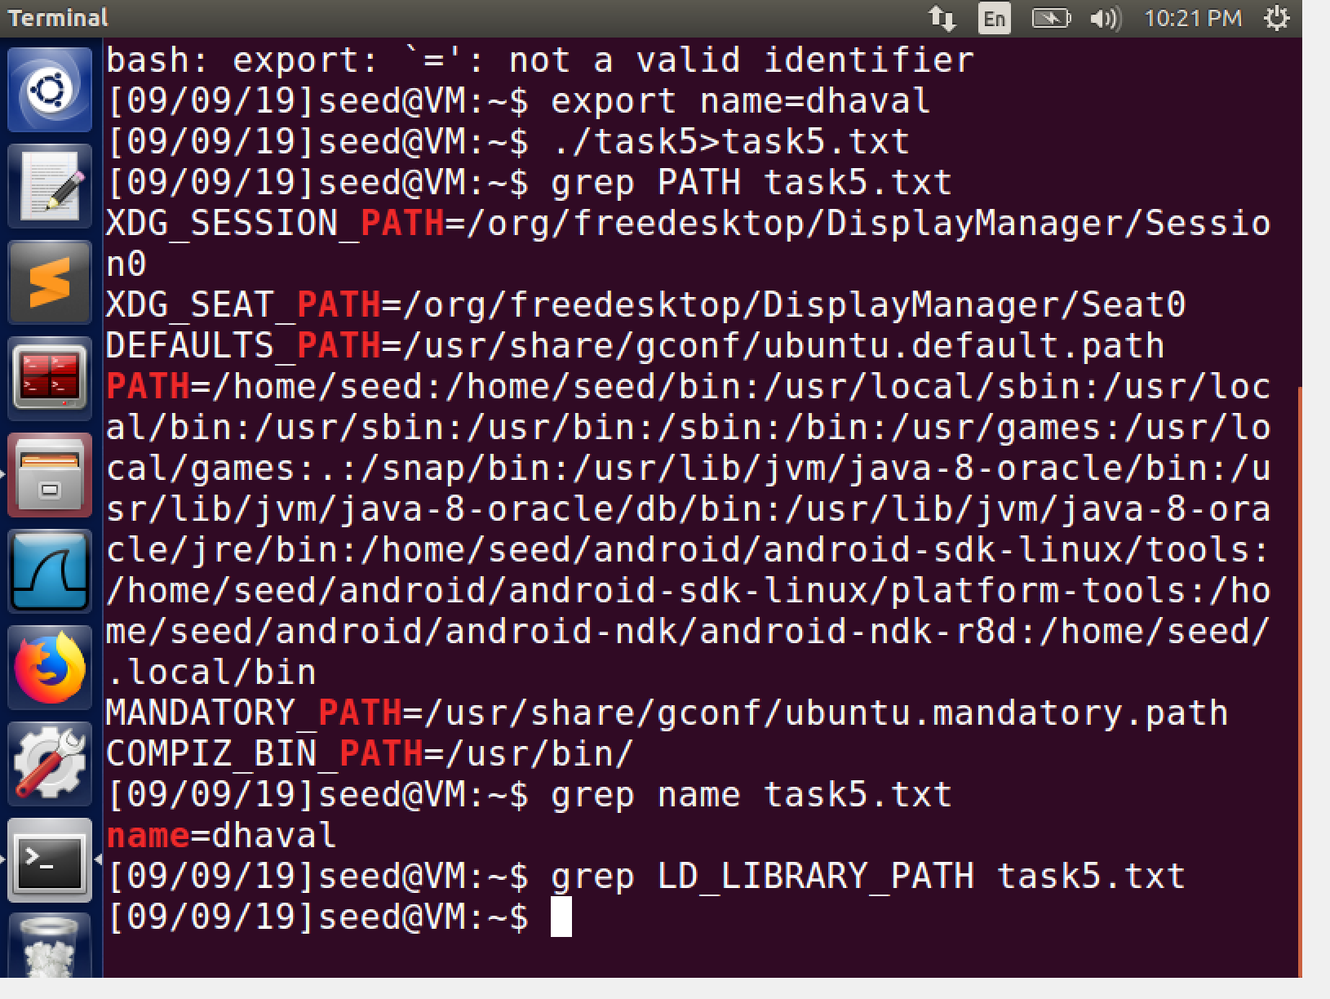

Task 6

To run our command instead of the command defined we will use environment variables.

To do this we first change the environment variables. We append the environment variables with a path where we will store or malicious ls file which will get executed.

Export PATH=/home/seed:$PATH does this

Now the system call will search in /home/seed before looking at /bin/ls

This is how we can run our code in a set uid program and gain root privilege to run our commands

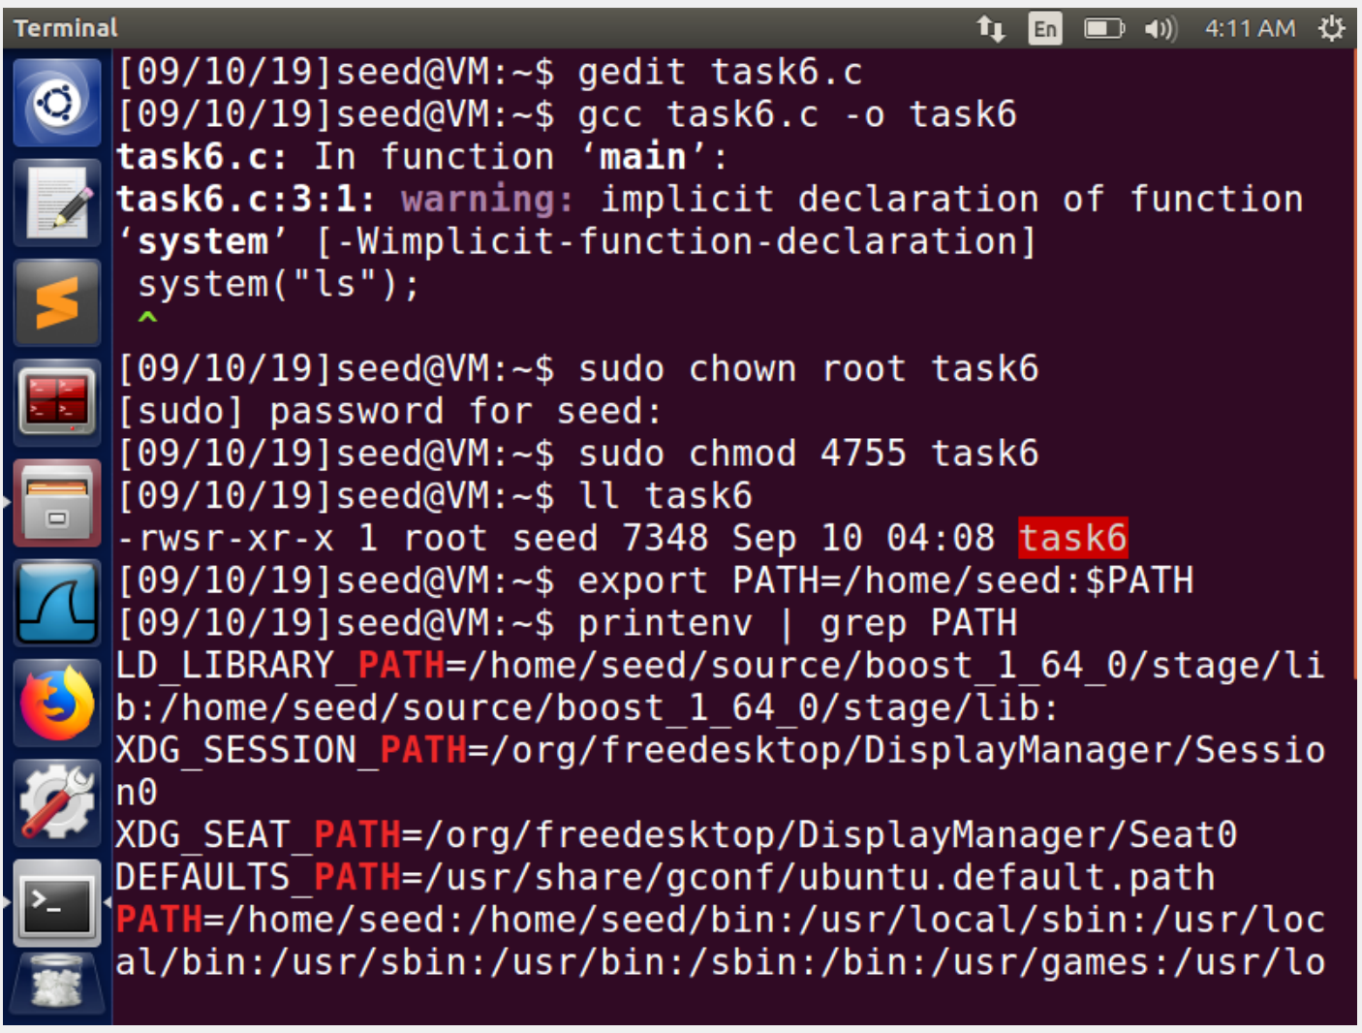

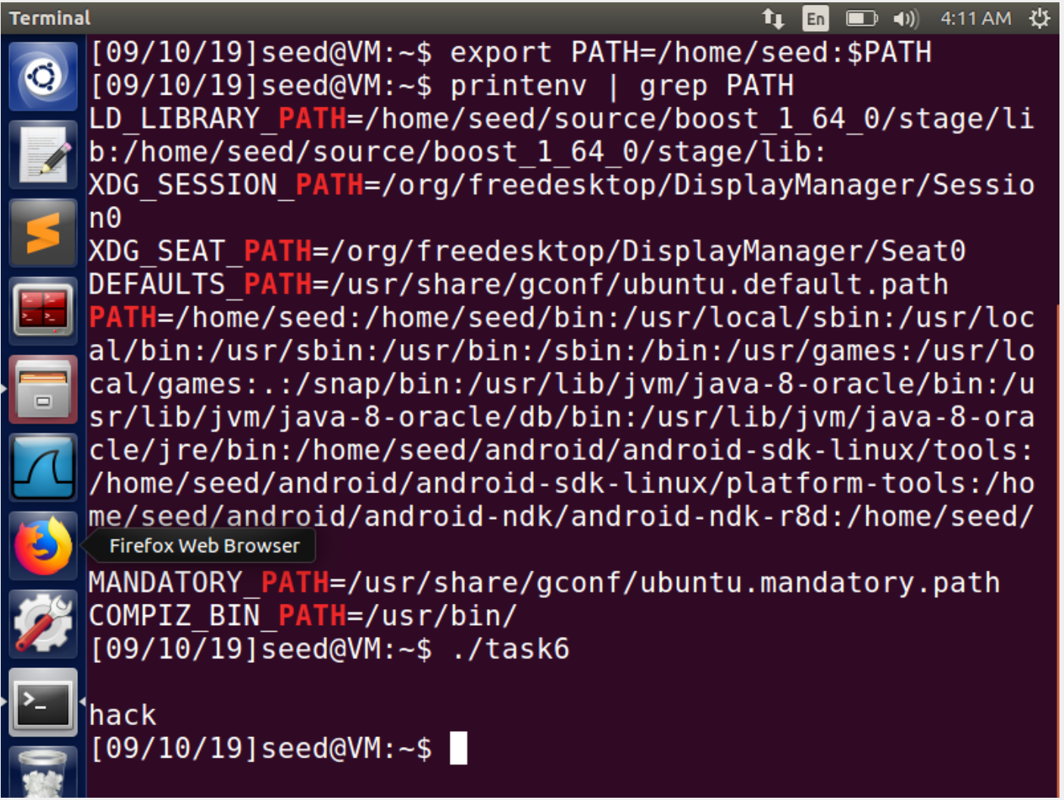

Task 7

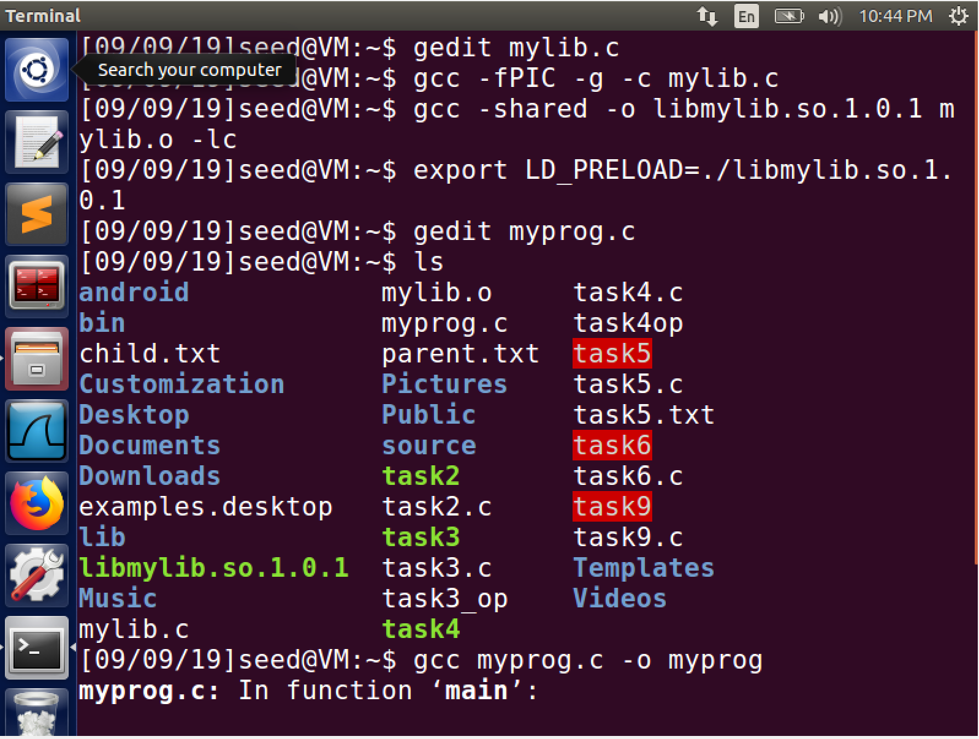

In this task we compile a dll and change the path variable of the LOADER using the LD_LIBRARY.

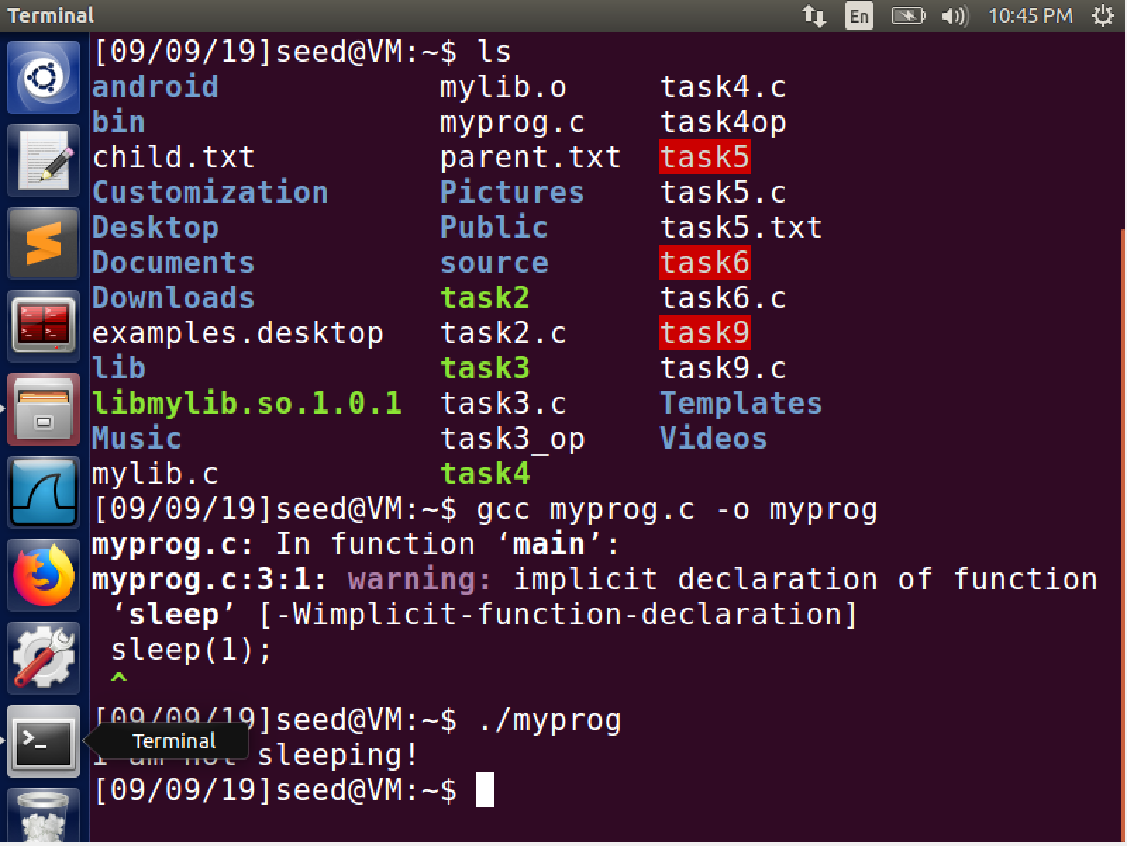

We now run the program and we can see that the dll works with the output. After that we make the program to a setuid program with root privileges and now we pass our dll as a variable and we have successfully run our program in the setuid program. Now we try and run the same run program with another user Bob and try to export the same environment variable, the screenshot shows that we fail and our malicious sleep is not executed. This shows that the LD_PRELOAD variable has protection while executing with a different user.

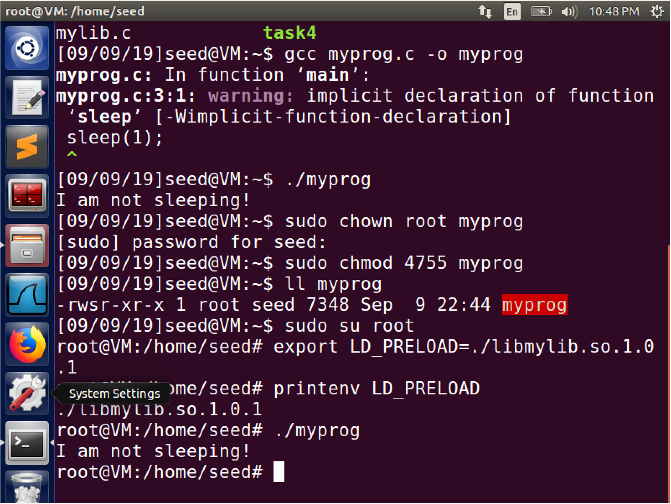

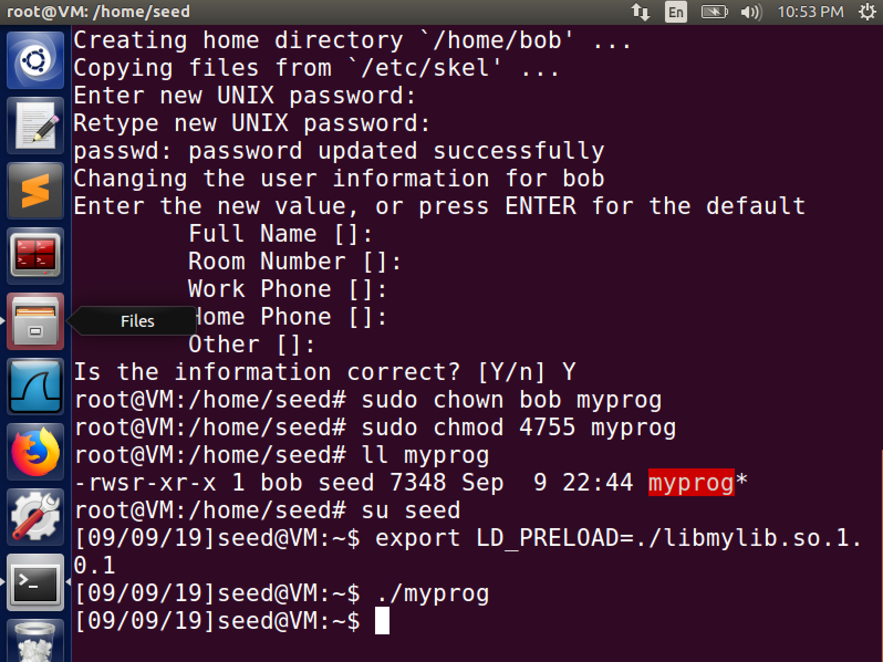

Task 8

We first define the system() and execve() programs to make the distinction between the cases clear.

System()

Uses the program owners shell and passes all the parameters as is. Hence there is a possibility of malicious execution.

Execve(function to call,parameters to pass,environment variables)

The function declaration of the execve shows why it is much better than System()

Scenario:

We create two files; namely auditFileToDelete.txt and auditFile.txt, both of them are owned by root and hence Bob has permission only to use them.

Case 1: System()

We separate our malicious code to delete the audit file using a semicolon the System() function takes it as is and deletes the file. Screenshot 1 proves this.

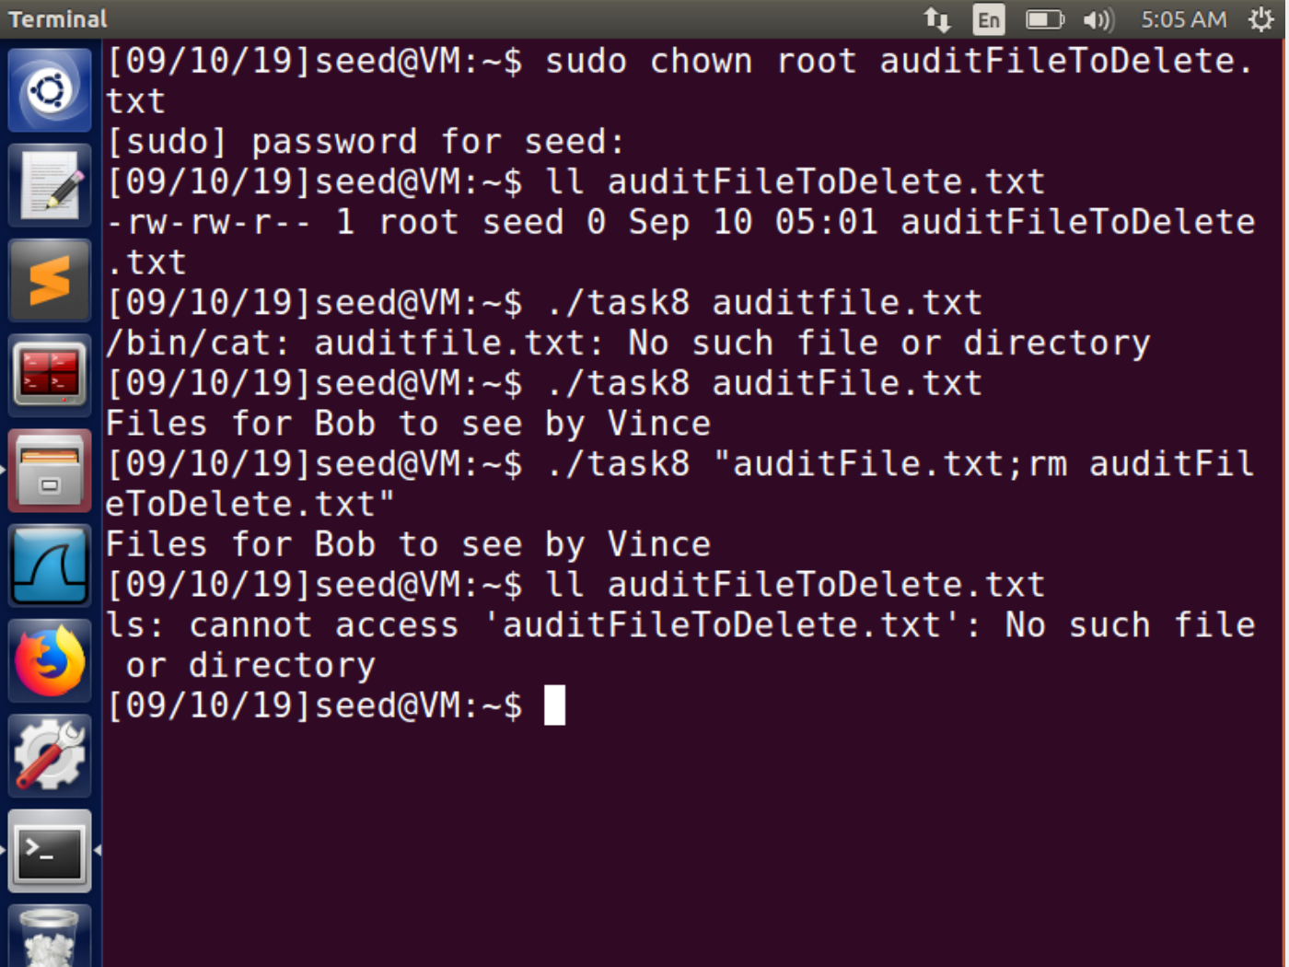

Case 2 Execve()

Doing the same attack with execve() is not possible as th efunction to call is defined inside the program Vince created. All our arguments are actually passed as arguments itself making it tougher to attack or delete the file.

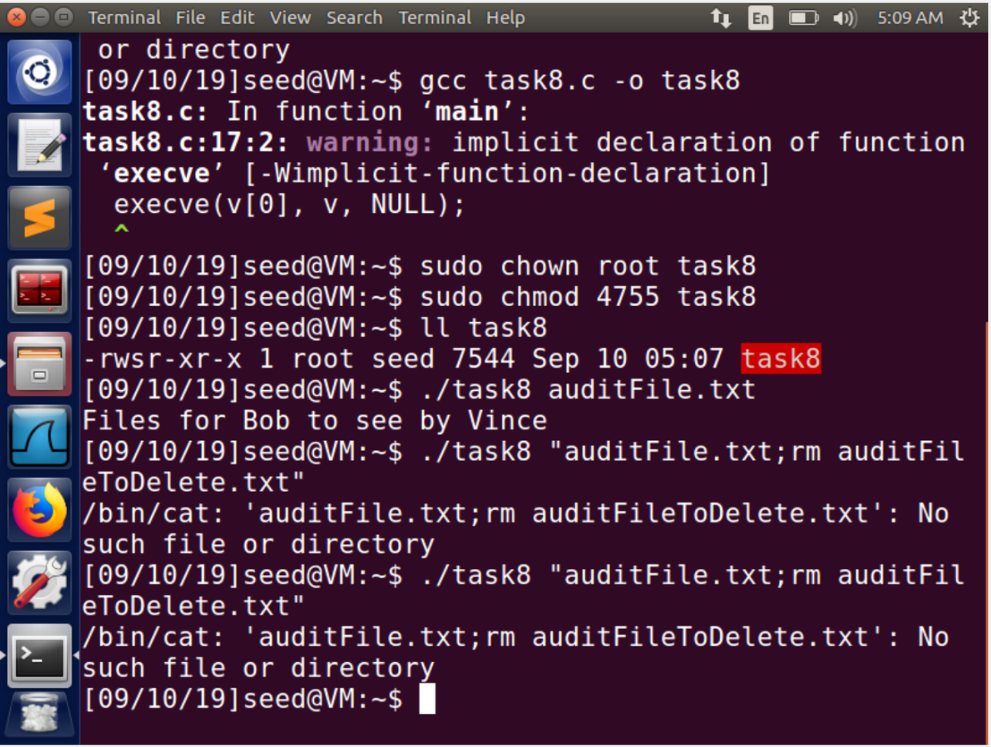

Task 9

Screenshot 1

Shows the compilation of the task9 program and the creation of binary file task9.

Screenshot 2

Here we make the task9 program a SetUID program using the chown and chmod commands and setting the setuid bit using the su privileges which makes the effective user id as root.

Screenshot 3

Shows creation of /etc/zzz file we change the rwx privileges so exemplify that only root can edit it.

Screenshot 4

We run task9, which runs the malicious code showing that the capability to write the file has been leaked by the file writer variable. The solution would be to get rid of such a file opener as soon as we finish using it.

